Hart County Board of Commissioners
May 27, 2014
5:30 p.m.

- PRAYER

- PLEDGE OF ALLEGIANCE

- CALL TO ORDER

- WELCOME

- APPROVE AGENDA

- APPROVE MINUTES OF PREVIOUS MEETING(S)
- 5/13/14 Regular Meeting
- 5/19/14 Called Meeting

- REMARKS BY INVITED GUESTS, COMMITTEES, AUTHORITIES

- REPORTS BY CONSTITUTIONAL OFFICERS & DEPARTMENT HEADS

- COUNTY ADMINISTRATOR’S REPORT

- CHAIRMAN’S REPORT

- COMMISSIONERS’ REPORTS

- OLD BUSINESS
a) HCWSA Appointment Discussion (tabled action)
b) Automatic Aid Fire Agreement with Elbert County
c) Updates and Discussion on Tax Issue Action Register Deliverables
d) Resource Plan for Tax Commissioners Office to Audit Refund Checks

- NEW BUSINESS
- Garden Club-Courthouse Grounds
- Bid Opening Rec Football/soccer Mass Grading Bid
- Bid Opening Rec Football/soccer Fine Grade/irrigation/sod
- Bid Opening Rec Football/soccer Sewer and Potable Water
- FY15 First Draft Budget

- PUBLIC COMMENT

- EXECUTIVE SESSION – Personnel and Potential Litigation Matters

- ADJOURNMENT

Hart County Board of Commissioners
May 27, 2014
5:30 p.m.

Hart County Board of Commissioners met May 27, 2014 at 5:30 p.m. at the Hart County Administrative & Emergency Services Center.
Chairman Joey Dorsey presided with Commissioners R C Oglesby, Frankie Teasley, Jimmy Carey and William Myers in attendance.
- Prayer
Prayer was offered by Rev. Brad Goss.
- Pledge of Allegiance
Everyone stood in observance of the Pledge of Allegiance.
- Call to Order
Chairman Dorsey called the meeting to order.
- Welcome
Chairman Dorsey welcomed those in attendance.
- Approve Agenda
Commissioner Oglesby moved to amend and approve the meeting agenda to include Executive Session – personnel and potential litigation matters. Commissioner Myers provided a second to the motion. The motion carried 5-0.
- Approve Minutes of Previous Meeting(s)
- 5/13/14 Regular Meeting
- 5/19/14 Called Meeting
Commissioner Carey moved to approve the minutes of the May 13 and May 19, 2014 meeting. Commissioner Myers provided a second to the motion. The motion carried 5-0.
- Remarks By Invited Guests, Committees, Authorities
None
- Reports By Constitutional Officers & Department Heads
County Attorney Walter Gordon thanked everyone involved with the Lake Hartwell Music Festival and was happy to report that the event was a success. He asked that the BOC consider allowing the promoters to reserve Lake Point Recreation area for next year’s music event.
- County Administrator’s Report
County Administrator Jon Caime reported the GDOT representatives will hold their annual STIP meeting June 5, 2014 at 1:00 p.m. at the Administrative facility.
- Chairman’s Report
Chairman Dorsey reported that according to GDOT’s press release a contract will be awarded for State Route 51 E road project in late August.
- Commissioners’ Reports
Commissioner Teasley reported that Whitworth Women’s facility parolees are continuing to pick up litter along the county roadways.
Commissioner Carey reported that the Memorial Day events beginning with the annual “Cars & Guitars” Festival and ending with the Lake Hartwell Music Festival was a success.
Commissioner Myers reported that the Challenge of the Centuries 2-day Bike Ride was part of the weekend of events.
- Old Business
- HCWSA Appointment Discussion (tabled action) (Term expires 3/1/2018)
Commissioner Oglesby moved to remove the item from the table. Commissioner Carey provided a second to the motion. The motion carried 5-0.
Commissioner Teasley moved to appoint Jerry Cannady to serve on the Hart County Water & Sewer Authority. Commissioner Myers provided a second to the motion. The motion carried 5-0.
- Automatic Aid Fire Agreement with Elbert County
Commissioner Myers moved to ratify the agreement with Elbert County. Commissioner Teasley provided a second to the motion. The motion carried 5-0.
- Updates and Discussion on Tax Issue Action Register Deliverables
County Administrator Caime explained that tax refunds were issued for 2009-2011 to property owners if the amount was greater than $5. However, for the years 2009 2,480 bills remain to be paid; 2010 2,700 bills remain to be paid; 2011 2,100 bills remain to be paid for approximately $2.4 million; $283,000 of refund will need to be hand audited before mailing out.
Tax Commissioner Pierce reported 5,200 refund checks cleared the bank; 1,000 refund checks were pulled and staff began reviewing them last week, of which 700 were mailed. Staff needs to clarify the transfers; go through returned mail due to incorrect addresses; review checks that were issued to deceased or estates all of which is a slow process. It also takes staff 10 -20 minutes per transaction to review the remaining refunds.
County Administrator Caime stated at some point the 5,200 refund checks will need to be audited.
Chairman Dorsey asked for a time frame for the action items discussed at the May 19, 2014 meeting. Tax Commissioner Pierce that he does not have a time frame to finalize the listed items.
Commissioner Teasley inquired about a tax sale for delinquent taxes for the periods of 2009 – 2011. Tax Commissioner Pierce responded that he is discussing intent to FIFA letters with the possibility of a tax sell by year end.
Chief Appraiser Wayne Patrick reported that the Board of Assessors needs to approve the letter that is drafted concerning mobile homes prior to mailing out.
Chairman Dorsey stated that he appreciates everyone’s efforts and the discussion on deliverables will carry over to the next meeting. He also reported that the county is facing a cash flow crunch in the near future.
- Resource Plan for Tax Commissioners Office to Audit Refund Checks
An update will be presented at the next BOC meeting.
- New Business
- Garden Club – Courthouse Grounds
Sheri Griggs representing the Garden Club stated that the various Garden Clubs contributed funds for the beautification project around the courthouse square. The club requested $1,500 annually to maintain their investment of landscaping on the courthouse grounds.
Commissioner Carey commented that he would take personal responsibility to fund the request.
DDA Director Henley Cleary commented on the subject.
Commissioner Oglesby moved to fund the request of $1,500 annually and waive the county’s bidding process. Commissioner Myers provided a second to the motion.
Chairman Dorsey commented that he is not opposed of the funding request that the board needs to work through the budget crunch before approve additional funding.
The motion carried 4-1 (Chairman Dorsey opposed).
- Bid Opening Rec Football/soccer Mass Grading Bid
Sealed bids were opened from B&M Excavating, IBC Construction, J G Leone Enterprises and Knott Construction.
Commissioner Myers moved to defer the bids to County Administrator Caime and Recreation Director Owens for review and recommendation. Commissioner Carey provided a second to the motion. The motion carried 5-0.
- Bid Opening Rec Football/soccer Fine Grade/irrigation/sod
Sealed bids were opened from Athletic Fields Inc., College Pro Landscaping, Knott Construction Inc., Precision Turf LLC, Red Oak Sports Inc. and Sports Turf Co. Inc.
Commissioner Oglesby moved to defer the bid to County Administrator Caime and Recreation Director Owens for review and recommendation. Chairman Dorsey provided a second to the motion. The motion carried 5-0.
- Bid Opening Rec Football/soccer Sewer and Potable Water
Sealed bids were opened from Bowen Utilities, B&M Excavating, J G Leone Enterprises, Long & Sons Utility and Knott Construction.
Commissioner Oglesby moved to defer the bids to County Administrator Caime and Recreation Director Owens for review and recommendation. Commissioner Carey provided a second to the motion. The motion carried 5-0.
- FY15 First Draft Budget
County Administrator Caime presented the first draft of the FY15 budget. He explained that the windfall that has been mentioned is yet to materialize. The 2012 digest consisted of ERA’s which resulted in a loss of tax revenues for 2012 forward; LOST revenues have decreased; reserves have been drawn down from General Fund and other Special Revenue Funds which will result in the BOC reviewing the entire picture for the upcoming year. He presented cash flow models and stressed that it is extremely important not to go below 25% fund reserves.
Chairman Dorsey stated the fiscal year ends September 30 and the county will need funds to carry through until tax revenues come in later in the year.
- Public Comment
Industrial Building Authority Chairman Doug Cleveland clarified the comment published in the letter to the editor that Hart County Industrial Authority nor the Joint Development Authority issued any kind of support, were not asked and did not contribute to the new development project in S.C.
Nicki Meyer thanked the BOC for their insight to take over the Long Point Park and there was a great turnout for the weekend events.
Mary Beth Foser commented on the funds issued to TORCH.
- Executive Session – Personnel/Potential Litigation
Commissioner Oglesby moved to exit into Executive Session to discuss personnel and potential litigation matters. Commissioner Myers provided a second to the motion. The motion carried 5-0.
With no further action taken during Executive Session, Commissioner Oglesby moved to exit and convene the regular meeting. Commissioner Carey provided a second to the motion. The motion carried 5-0.
- Adjournment
Commissioner Teasley moved to adjourn the meeting. Commissioner Carey provided a second to the motion. The motion carried 4-0 (Commissioner Oglesby was absent).

---------------------------------------------------------------- ----------------------------------------------------------
Joey Dorsey, Chairman Lawana Kahn, County Clerk

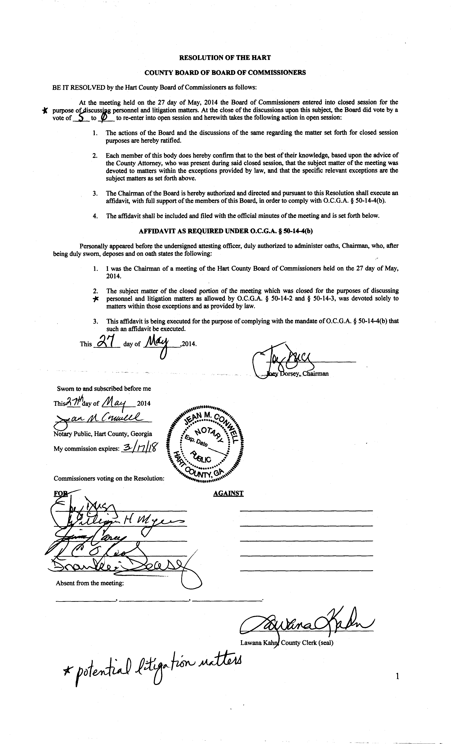

Hart County Board of Commissioners
Budget Called Meeting
May 27, 2014
After Regular BOC 5:30 p.m. Meeting

Called Meeting
- Overview of 2014 Budget
- Discussion of Top 20 FY14 Budgets
- 33000 EMS $2,000,000+ Expense $725,000 Revenue
- 33000 Sheriff $2,000,000 Expense
- 42000 Roads $1,300,000 ($600k 203, $706k GF)
- 33260 Jail $1,100,000 Expense
- 540 Fund Solid Waste $1,000,000
- 215 Fund 911 Operations $520,000
- 49000 Maintenance Shop $483,000
- 15500 BOA $423,000
- 203 Fund Fire $400,000
- 13000 BOC $376,000
- 15450 Tax Commissioner $327,880
- 24500 Probate Court $324,052
- 21800 Clerk of Court $277,462
- 61000 Recreation $257,082
- 75000 Econ Dev. $238,091
- 24000 Magistrate Court $179,538
- 15500 Risk Mgt $143,000
- 55200 Senior Center $112,408
- 10000 General Government $98,300
- 21500 Superior Court $91,361

Hart County Board of Commissioners
Budget Called Meeting
May 27, 2014
After Regular BOC 5:30 p.m. meeting

Chairman Dorsey presided with Commissioners R C Oglesby, Frankie Teasley, Jimmy Carey and William Myers in attendance.
Chairman Dorsey called the meeting and reported that there could be a million dollar shortfall due to the issues with the tax collections etc. and there is a strong possibility the county may have to borrow money.
County Administrator Caime presented an overview of the 2014 budget.
Commissioner Oglesby moved to increase the EMS fee structure and non-transport calls will be charged effective June 1, 2014. Commissioner Carey provided a second to the motion. The motion carried 5-0.
The following items were cut from the current or either deferred from the budget:
- Personal time buyout for public safety employees will be deferred to the next fiscal year, the remaining holidays for FY14 will be deferred to the next fiscal year.
- Tax Assessors $5,000 (computers)
- Fire Department $1,000 (periodicals) $15,000 (pagers)
- Tax Commissioner $10,000 (temp wages)
- Clerk of Superior Court $2,000 (shelving) $1,000 (part time wages)
- Recreation $7,000 (temp wages)
Commissioner Myers moved to apply the budget cuts. Commissioner Carey provided a second to the motion. The motion carried 4-0 (Commissioner Oglesby left early).

----------------------------------------------------------- ----------------------------------------------------------
Joey Dorsey, Chairman Lawana Kahn, County Clerk

