Hart County Board of Commissioners
July 22, 2014
5:30 p.m.

- PRAYER

- PLEDGE OF ALLEGIANCE

- CALL TO ORDER

- WELCOME

- APPROVE AGENDA

- APPROVE MINUTES OF PREVIOUS MEETING(S)
- 7/8/14 Regular Meeting

- REMARKS BY INVITED GUESTS, COMMITTEES, AUTHORITIES

- REPORTS BY CONSTITUTIONAL OFFICERS & DEPARTMENT HEADS

- COUNTY ADMINISTRATOR’S REPORT

- CHAIRMAN’S REPORT

- COMMISSIONERS’ REPORTS

- OLD BUSINESS
- Rec Football Uniforms and Equipment Bid Award
- Rec Cheerleading Bid Award
- Rec Football Photography Bid Award
- Bid Award Rec Football/soccer Fine Grade/irrigation/sod
- LMIG Grant Application for FY15
- Fire hydrants/Ridge Road

- NEW BUSINESS
- BOE SRO Requests (Sheriff Mike Cleveland)
- COC Presentation
- Regional Orthophoto Project Participation

- PUBLIC COMMENT

- EXECUTIVE SESSION-Real Estate & Legal
- ADJOURNMENT

Hart County Board of Commissioners
July 22, 2014
5:30 p.m.

The Hart County Board of Commissioners met July 22, 2014 at 5:30 p.m. at the Hart County Administrative & Emergency Services Center.

Chairman Joey Dorsey presided with Commissioners R C Oglesby, Frankie Teasley, Jimmy Carey and William Myers in attendance.

- Prayer
Prayer was offered by Rev. Brad Goss.

- Pledge of Allegiance
Everyone stood in observance of the Pledge of Allegiance.

- Call to Order
Chairman Dorsey called the meeting to order.

- Welcome
Chairman Dorsey welcomed those in attendance.

- Approve Agenda
Commissioner Myers moved to approve the meeting agenda. Commissioner Carey provided a second to the motion. The motion carried 5-0.

- Approve Minutes of Previous Meeting(s)
- 7/8/14 Regular Meeting
Commissioner Teasley moved to approve the minutes of the July 8, 2014 meeting. Commissioner Carey provided a second to the motion. The motion carried 4-0 (Commissioner Myers abstained).

- Remarks by Invited Guests, Committees, Authorities
None

- Reports By Constitutional Officers & Department Heads
County Attorney Walter Gordon reported that the Water & Sewer Authority approved $3,000 toward the purchase of property in the Crossroads Community.

- County Administrator’s Report
County Administrator Jon Caime distributed the five year road plan to the BOC and announced that Diane Dobbs has been hired for the Election Superintendent position.

- Chairman’s Report
Chairman Dorsey reported that the Recreation Department needs to plan ahead for holiday weekends pertaining cleanup at the Long Point Rec. site. He also reported that a request is before the Hospital Authority to fund the ambulance substation, no commitment has been rendered.

- Commissioners’ Reports
Commissioner Teasley congratulated the 9-10 year old Little League team for their accomplishments; reported that the detail provided by Whitworth Women’s Facility continues to pick up trash along county roads.

Commissioner Teasley moved to direct County Administrator Jon Caime to draft a letter to the DOT to request road striping along Mt. Hebron Church Road. Commissioner Carey provided a second to the motion. The motion carried 5-0.

- Old Business
- Rec Football Uniforms and Equipment Bid Award
Commissioner Myers moved to award the bid to Dillard’s Sporting Goods. Commissioner Carey provided a second to the motion. The motion carried 4-1 (Commissioner Teasley opposed).

b) Rec Cheerleading Bid Award
Commissioner Myers moved to award the bid to Dillard’s Sporting Goods. Motion died from lack of a second.

Commissioner Oglesby moved to award the bid to Dillard’s Sporting Goods, increase the signup fee to $30 per person. Chairman Dorsey provided a second to the motion. The motion carried 5-0.

Commissioner Oglesby moved to increase the football signup fee to $55 going forward. Commissioner Carey provided a second to the motion. The motion carried 5-0.

- Rec Football Photography Bid Award
Chairman Dorsey moved to table the issue. Commissioner Teasley provided a second to the motion. The motion carried 5-0.

- Bid Award Rec Football/soccer Fine Grade/Irrigation/sod
Rec. Advisory Board member William Granger reported that Athletic Fields Inc. has performed work for UGA, Clemson, Florida State, N.C. State and is highly recommended.

Commissioner Carey requested the Rec. Advisory Board visit and/or contact other companies besides large scale complexes that Athletic Fields Inc. has contracted with for quality of work and results of after a year’s use of fields.

No action was taken.

- LMIG Grant Application for FY15
County Administrator Caime reported that the county’s match of 30% along with LMIG funding would pave approximately six miles of county roads.

No action was taken.

- Fire Hydrants/Ridge Road
Commissioner Oglesby moved to purchase seven fire hydrants from SPLOST fire funds to be installed by the City of Hartwell utility department along a six inch water line on Ridge Road. Chairman Dorsey provided a second to the motion. The motion carried 5-0.

- New Business
- BOE SRO Requests (Sheriff Mike Cleveland)
Commissioner Oglesby moved to allow the Sheriff to hire two full time school resource officers that will be funded by the Board of Education. Commissioner Carey provided a second to the motion. The motion carried 5-0.

- COC Presentation
Nicki Meyer recapped the Chamber sponsored events for January through May 2014; the Wet and Wild Weekend Event is scheduled for August 8 through 10 and the Farm Fest is in the planning stages for September 20.

Commissioner Carey commended Ms. Meyer for her efforts arranging events to attract participation and tourism for the county.

- Regional Orthophoto Project Participation
Commissioner Myers moved to approve the proposal as part of the Georgia Mountains Regional Commission’s regional project. Commissioner Carey provided a second to the motion. The motion carried 5-0.

- Public Comment
Mary Beth Foser commented about an issue on private property on Nancy Drive.

- Executive Session-Real Estate & Legal
Commissioner Oglesby moved to exit into Executive Session to discuss real estate and legal matters. Commissioner Myers provided a second to the motion. The motion carried 5-0.

With no further action taken during Executive Session, Commissioner Oglesby moved to exit and convene the regular meeting. Commissioner Myers provided a second to the motion. The motion carried 5-0.

The BOC considered the report of the Hearing Officer on the Brandy Cooper appeal hearing. Commissioner Carey moved to accept the recommendation of the Cooper Hearing Officer appeal affirming the termination decision. Commissioner Myers provided a second to the motion. The motion carried 5-0.

Commissioner Oglesby moved to approve the COC request to use county property for an event. Commissioner Myers provided a second to the motion. The motion carried 5-0.

- Adjournment
Commissioner Oglesby moved to adjourn the meeting. Commissioner Carey provided a second to the motion. The motion carried 5-0.

------------------------------------------------------------------- ----------------------------------------------------------------
Joey Dorsey, Chairman Lawana Kahn, County Clerk

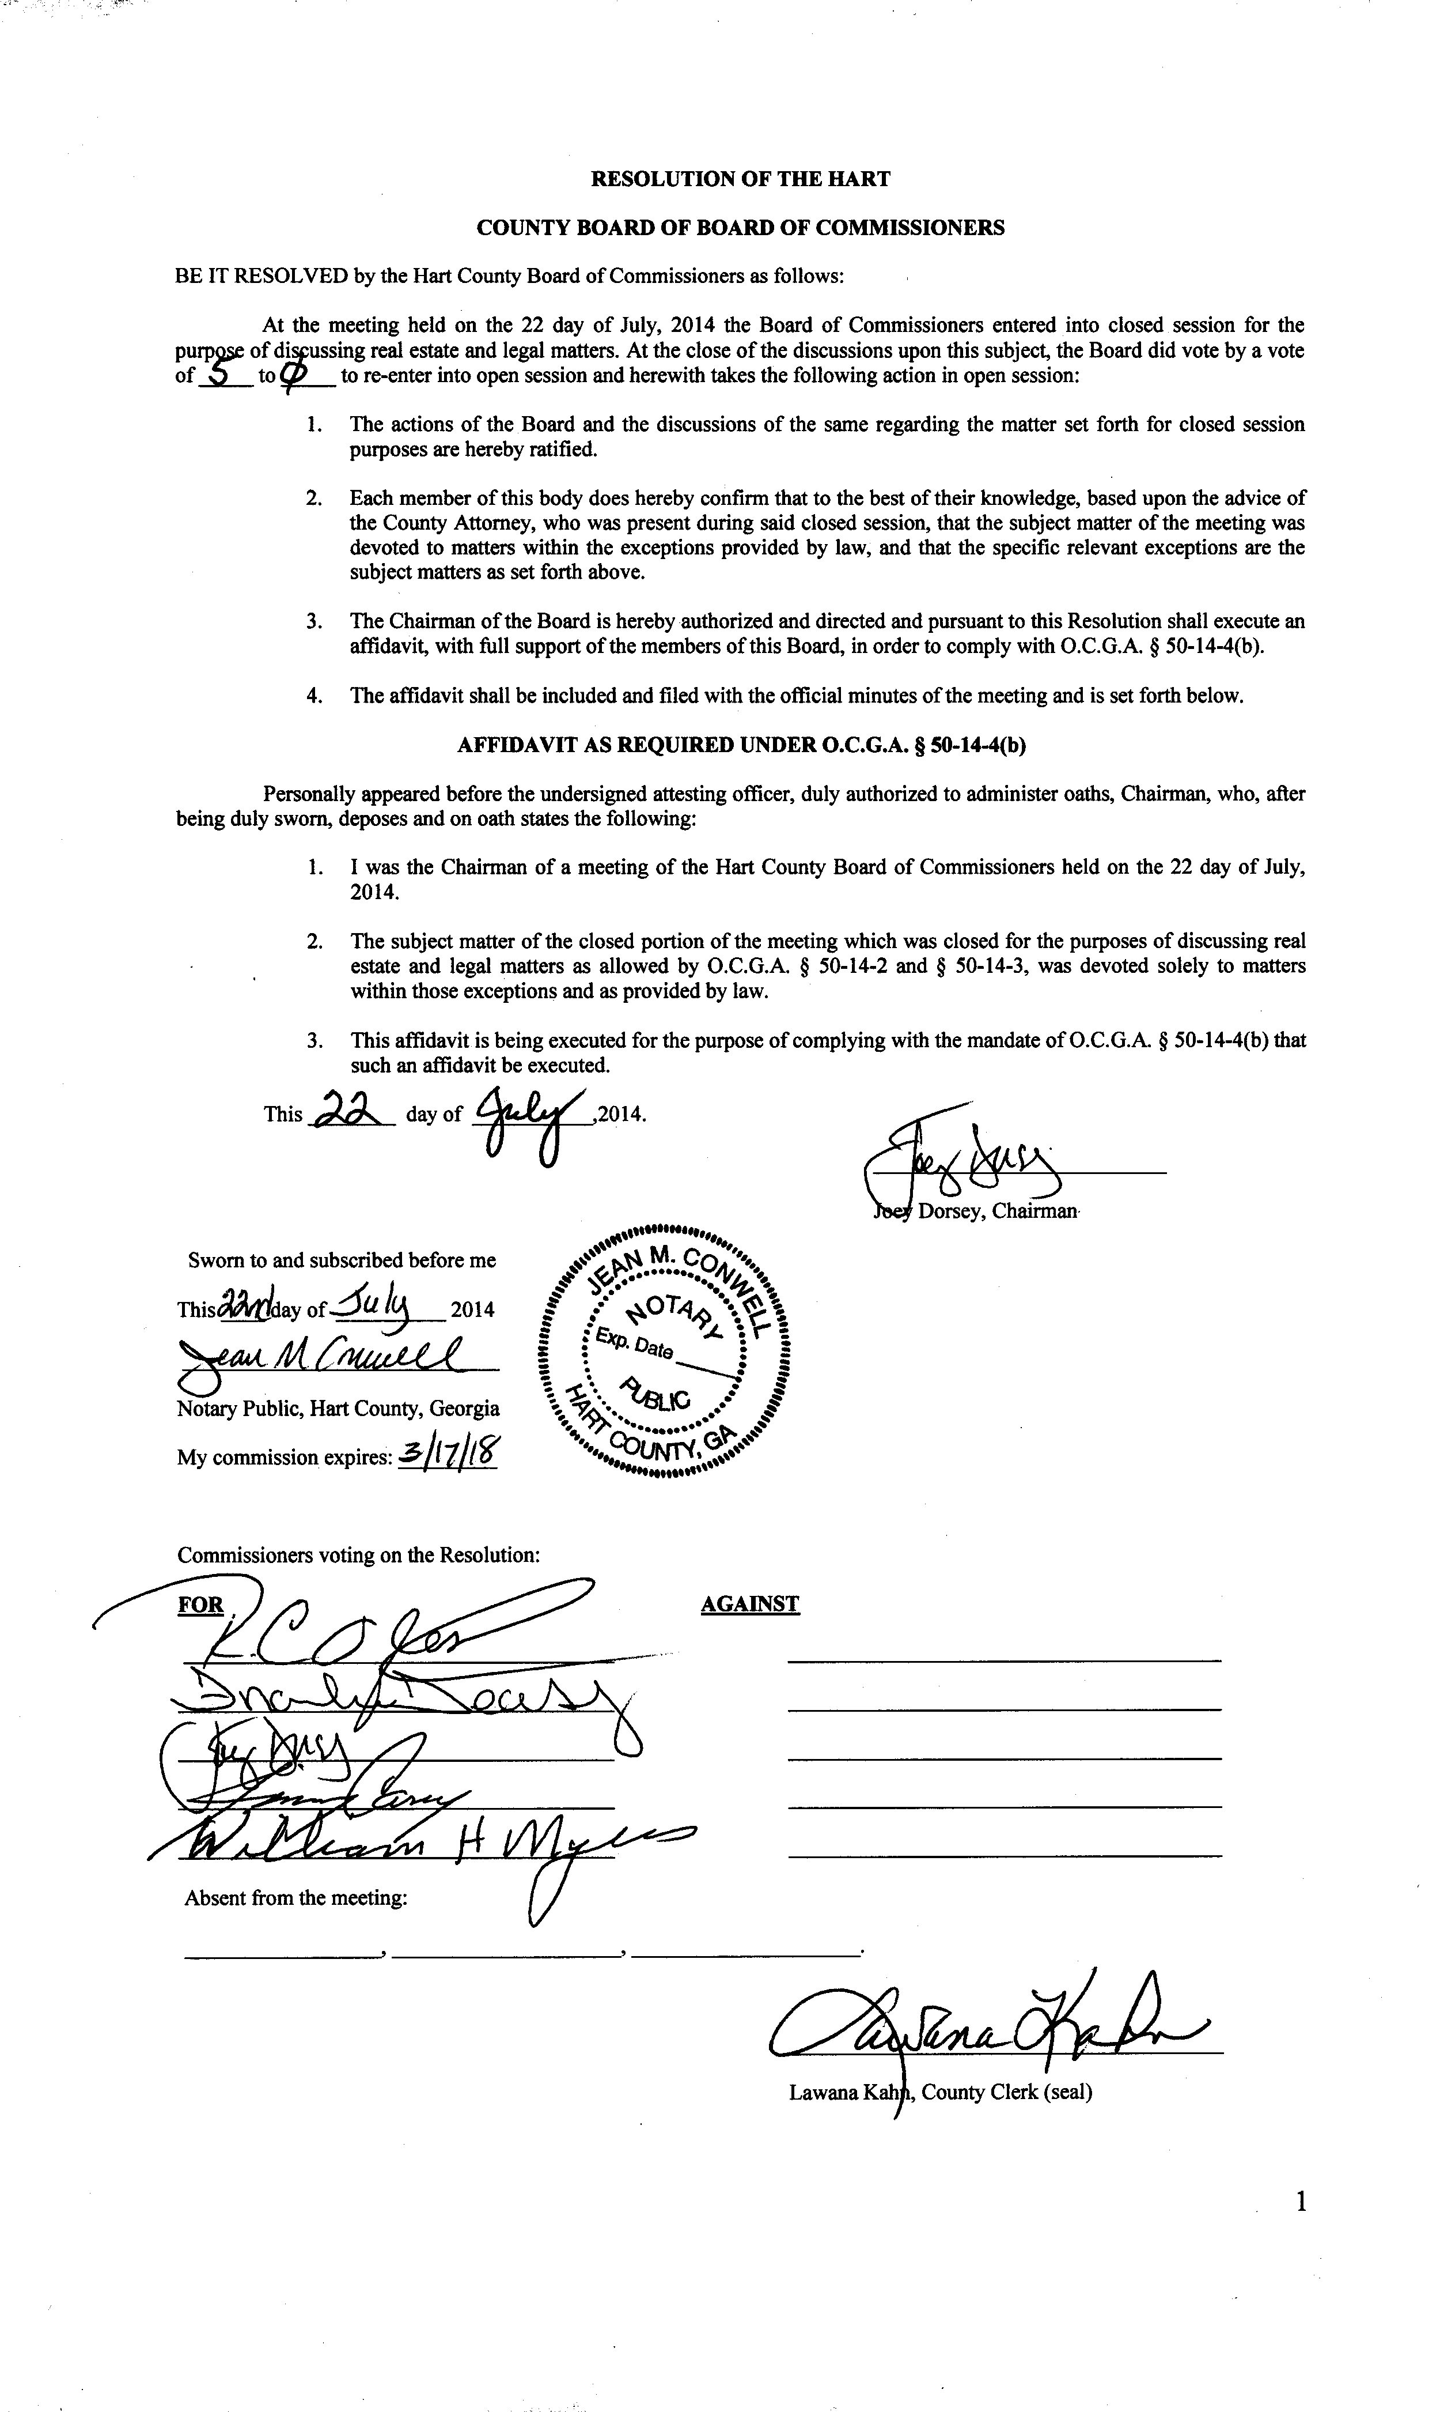

Hart County Board of Commissioners
Called Meeting
July 29, 2014
5:30 p.m.

Called Meeting
- Executive Session-Personnel

FY15 Budget:
- 15450 Tax Commissioner
- 15500 BOA
- 24000 Magistrate Court
- 21800 Clerk of Court
- 42000 Roads (203 & GF)
- 203 Other Fund Budgets- (Not fire or roads)
- 61000 Recreation
- 540 Fund Solid Waste
- 49000 Maintenance Shop
- 75000 Econ Dev.
- 15500 Risk Mgt
- 10000 General Government
- 21500 Superior Court
- 51000 Health Dept
- 54000 DFACs
- 34200 Adult Corrections
- Other Items As Time Allows

Remaining to be discussed:
- 55200 Senior Center
- 55400 Transit
- 24500 Probate Court
- 14100 BOR
- 14200 Board of Elections
- 13000 BOC
- 10000 General Government
- 15550 Risk Management
- 15300 LAW
- 15600 Internal Audit
- 15650 General Government- Buildings
- 15950 General Administration Fees
- 37000 Coroner
- 65100 Library
- 39100 Animal Control
- 75630 Airport
- 76300 Community Action
- 76400 Literacy Center
- 206 Beh Health SRF
- 216 DFACs Building SRF
- 251, 253, 254, 255, 256 EIP SRF
- 250 Multiple Grants SRF
- 322 SP2
- 71300 Ag Resources
- 323 SPLOST3
- 324 SPLOST4
- GF Revs

Already Discussed
- 33000 Sheriff
- 33260 Jail
- 201 DARE SRF
- 204 Jail Fund SRF
- 33000 EMS
- 39200 EMA
- 215 Fund 911 Operations
- 203 Fund Fire
- 28000 Public Defender

Hart County Board of Commissioners
July 29, 2014
Called Meeting
5:30 p.m.

The Hart County Board of Commissioners met July 29, 2014 at the Hart County Administrative Building.

Chairman Joey Dorsey presided with Commissioners R C Oglesby, Frankie Teasley, Jimmy Carey and William Myers in attendance.

Commissioner Carey made a motion to add Recreation Photography bid to the agenda. Commissioner Teasley provided a second to the motion and the motion passed 5-0.

Commissioner Oglesby made a motion to exit into executive session for the purpose of discussing a personnel matter. Chairman Dorsey provided a second to the motion and the motion passed 5-0.

Commissioner Carey made a motion to exit executive session and reenter the regular meeting. Commissioner Myers provided a second to the motion and the motion passed 5-0.

In the regular meeting Chairman Dorsey made a motion to contact the ACCG to obtain independent legal counsel to advise the BOC on certain matters regarding the Probate Judge. Commissioner Myers provided a second to the motion and the motion passed 5-0.

Commissioner Carey made a motion to hire Janet McCart for the interim Elections Superintendent until the conclusion of the November election. Commissioner Teasley provided a second to the motion and the motion passed 5-0.

Chairman Dorsey made a motion to authorize the entry level pay of $49,722 to the Chief Probate Clerk Merry Kirk in the absence of the Probate Judge. Commissioner Myers provided a second to the motion and the motion passed 5-0.

Chairman Dorsey made a motion to take the recreation photography bid off the table. Commissioner Carey provided a second to the motion and the motion passed 5-0.

At the recommendation of the Recreation Director, Commissioner Carey made a motion to award the bid to the low bidder Lifetouch. Commissioner Meyers provided a second to the motion and the motion passed 5-0.

The BOC discussed the following budgets: 15500 BOA, 24000 Magistrate Court, 21800 Clerk of Court, 61000 Recreation and 75000 Chamber of Commerce

Commissioner Oglesby made a motion to adjourn, Commissioner Carey provided a second to the motion and the motion passed 5-0.

-------------------------------------------------------- ---------------------------------------------
Joey Dorsey, Chairman Lawana Kahn, County Clerk

