Hart County Board of Commissioners
June 10, 2014
5:30 p.m.
- PRAYER

- PLEDGE OF ALLEGIANCE

- CALL TO ORDER

- WELCOME

- APPROVE AGENDA

- APPROVE MINUTES OF PREVIOUS MEETING(S)
- 5/27/14 Regular Meeting
- 5/27/14 Called Budget Meeting

- REMARKS BY INVITED GUESTS, COMMITTEES, AUTHORITIES

- REPORTS BY CONSTITUTIONAL OFFICERS & DEPARTMENT HEADS

- COUNTY ADMINISTRATOR’S REPORT

- CHAIRMAN’S REPORT

- COMMISSIONERS’ REPORTS

- OLD BUSINESS
a) Tax Commissioners Office- Refund Audit Update
b) Bid Award Rec Football/soccer Mass Grading Bid
c) Bid Award Rec Football/soccer Sewer and Potable Water
d) DFACs Board Appointment

13. NEW BUSINESS
- Hearing Officer Appointment Employee Termination Appeal
- DHS Transit Contract with GMRC
- Public Defender FY15 Budget Approval
- Discussion 3 Way Stop Sign/Atkins Lunsford, Tom Rice & Farm Roads

14. PUBLIC COMMENT

15. EXECUTIVE SESSION-Personnel/Potential Litigation

16. ADJOURNMENT

Hart County Board of Commissioners
June 10, 2014
5:30 p.m.

The Hart County Board of Commissioners met June 10, 2014 at 5:30 p.m. at the Hart County Administrative & Emergency Services Center.

Chairman Joey Dorsey presided with Commissioners R C Oglesby, Frankie Teasley, Jimmy Carey and William Myers in attendance.

- Prayer
Prayer was offered by Rev. Brad Goss.

- Pledge of Allegiance
Everyone stood in observance of the Pledge of Allegiance.

- Call to Order
Chairman Dorsey called the meeting to order.

- Welcome
Chairman Dorsey welcomed those in attendance.

- Approve Agenda
Commissioner Oglesby moved to amend and approve the meeting agenda to include Executive Session-potential litigation and 13d) Discussion 3 way stop sign Atkins Lunsford, Tom Rice and Farm Roads. Commissioner Myers provided a second to the motion. The motion carried 5-0.

- Approve Minutes of Previous Meeting(s)
- 5/27/14 Regular Meeting
- 5/27/14 Called Budget Meeting

Commissioner Oglesby moved to approve the minutes of the May 27 meetings. Commissioner Carey provided a second to the motion. The motion carried 5-0.

- Remarks By Invited Guests, Committees, Authorities
None

- Reports By Constitutional Officers & Department Heads
County Attorney Walter Gordon did not have anything to report.

- County Administrator’s Report
County Administrator Jon Caime reported that the DOT is paying for the water line re-route on Parham Road due to the sink hole on 51; considering an alternative detour route during the water line construction; thanked Warden Benton and Sgt. Reid for supplying work detail labor to pick up trash along county rights of way. He reported the work detail crews have picked up a ton of trash during the past several weeks and also assisted at the Recreation parks.

- Chairman’s Report
Chairman Dorsey reported a budget work session will follow the regular meetings in order to complete the FY15 budget by the end of August; anticipating the digest and tax bills go out as scheduled for the first time in five years.

- Commissioners’ Reports
Commissioner Teasley reported that Whitworth will be supplying details to clean government buildings; the DOT will be possibly stripe lines along Parham Road and discussed bush hogging the road. He thanked the Sheriff’s Office and State Patrol for patrolling the area during the DOT construction phase of the project on highway 51.

Commissioner Myers invited the public to attend an ISO meeting June 12, 2014 at the Adult Literacy Center.

- Old Business
- Tax Commissioners Office – Refund Audit Update
County Administrator Caime commented on uncollected taxes.

Chairman Dorsey requested an update from Tax Commissioner Pierce at the June 24, 2014 meeting.

- Bid Award Rec Football/soccer Mass Grading Bid
Commissioner Oglesby moved to award the bid to B&M Excavating. Commissioner Myers provided a second to the motion. The motion carried 5-0.

- Bid Award Rec Football/soccer Sewer and Potable Water
PW Director Jon Caime explained for the record that the low bidder did not acknowledge addendum #2 on their bid however the bidder did acknowledge this in their bid for the mass grading which was the exact same addendum. Commissioner Oglesby moved to award the bid to B&M Excavating noting this discrepancy. Commissioner Carey provided a second to the motion. The motion carried 5-0.

- DFACs Board Appointment (term expires 6/30/2019)
Commissioner Oglesby moved to re-appoint Earnestine White to serve on the DFACs board. Commissioner Myers provided a second to the motion. The motion carried 5-0.

- New Business
- Hearing Officer Appointment Employee Termination Appeal
Commissioner Oglesby moved to appoint Attorney Douglas Kidd to serve as the hearing officer for the termination of employment appeal. Commissioner Myers provided a second to the motion.

Chairman Dorsey requested County Attorney Gordon to explore the possibility of utilizing a Magistrate Judge from surrounding counties as a hearing officer in the future.

With no further comments, Chairman Dorsey called for the vote. The motion carried 5-0 to appoint Attorney Kidd as the hearing officer.

- DHS Transit Contract with GMRC
Commissioner Myers moved to approve the contract for DHS transit services. Commissioner Carey provided a second to the motion. The motion carried 5-0.

- Public Defender FY15 Budget Approval
County Attorney Gordon reported that Hart County’s share of the Public Defender’s FY15 budget decreased by approximately $3,000.

Commissioner Carey moved to approve the budget; adopt the budget resolution and authorize the chairman to execute the resolution. Commissioner Teasley provided a second to the motion. The motion carried 5-0.

- Discussion 3 way stop sign/Akins Lunsford, Tom Rice and Farm Roads
Chairman Dorsey moved to authorize County Administrator Caime to draft a letter to GDOT for review and recommendation concerning the 3 way stop at the intersections of Akins Lunsford, Tom Rice and Farm Roads. Commissioner Teasley provided a second to the motion. The motion carried 5-0.

- Public Comment
None

- Executive Session – Personnel/Potential Litigation
Commissioner Myers moved to exit into Executive Session to discuss personnel and potential litigation matters. Commissioner Carey provided a second to the motion. The motion carried 5-0.

With no further action taken during Executive Session, Commissioner Oglesby moved to exit and convene the regular meeting. Commissioner Myers provided a second to the motion. The motion carried 5-0.

- Adjournment
Commissioner Carey moved to adjourn the meeting. Commissioner Teasley provided a second to the motion. The motion carried 5-0.

----------------------------------------------------------------- -----------------------------------------------------------Joey Dorsey, Chairman Lawana Kahn, County Clerk

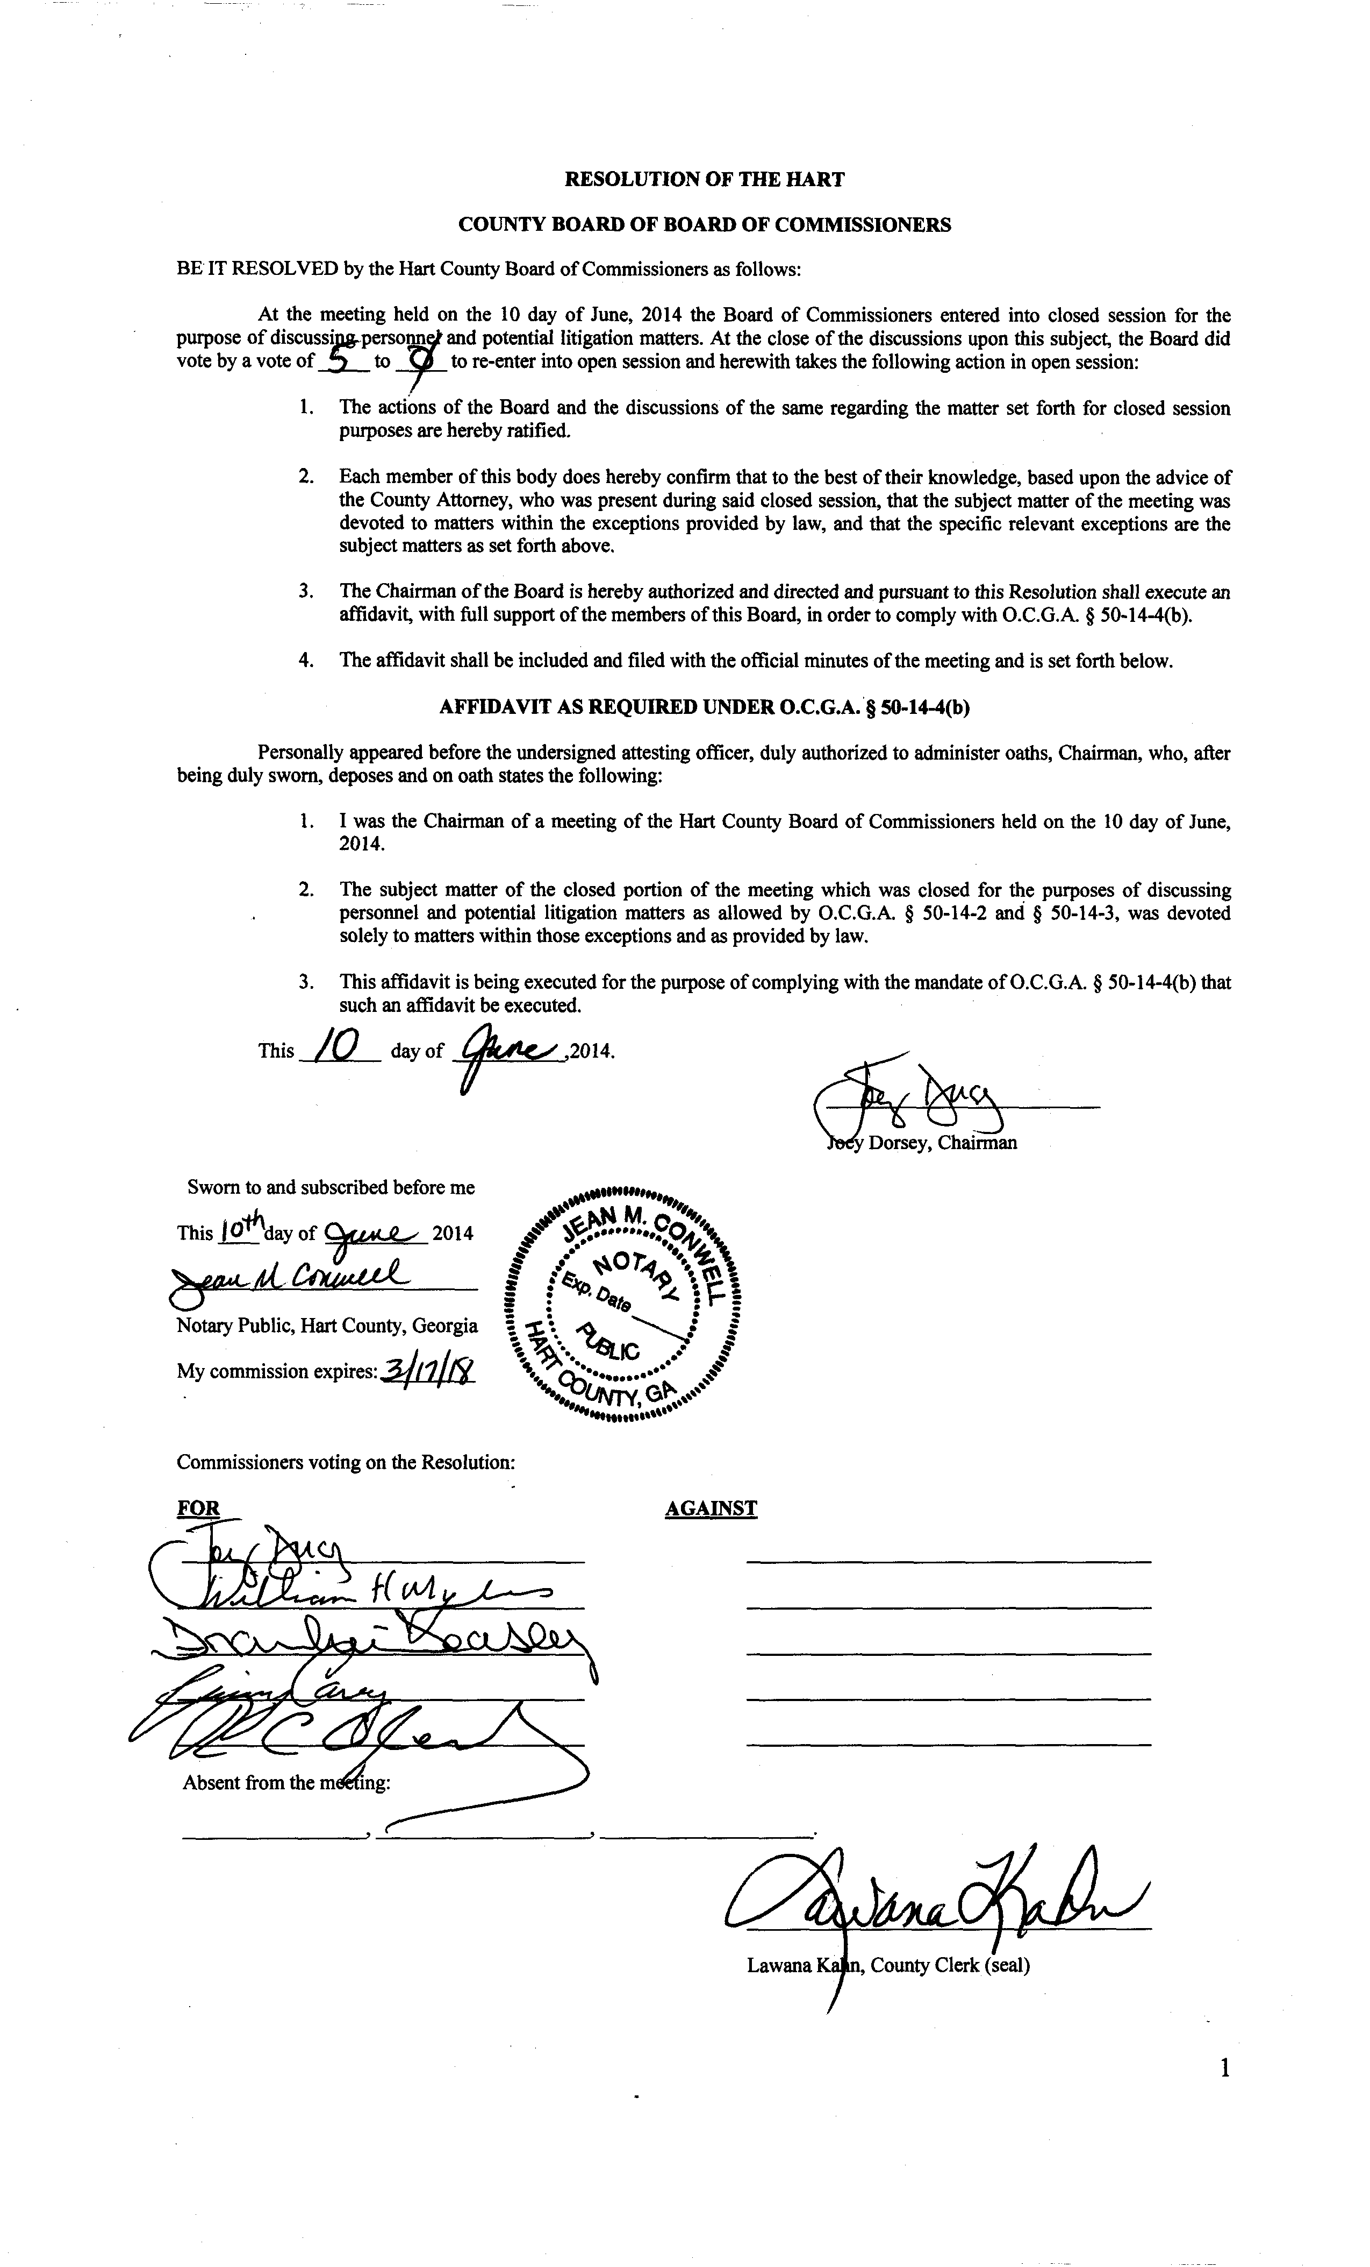

Hart County Board of Commissioners
Budget Called Meeting
June 10, 2014
After Regular BOC 5:30 p.m. Meeting
Called Meeting FY15 Budget
- 33000 Sheriff
- 33260 Jail
- 201 DARE SRF
- 204 Jail Fund SRF
- 33000 EMS
- 39200 EMA
- 215 Fund 911 Operations
- 42000 Roads (203 & GF)
- 203 Fund Fire
- Remaining 203 Fund Budgets
- 540 Fund Solid Waste
- 49000 Maintenance Shop

Remaining to be discussed:
- 15500 BOA
- 15450 Tax Commissioner
- 24500 Probate Court
- 24000 Magistrate Court
- 21800 Clerk of Court
- 61000 Recreation
- 75000 Econ Dev.
- 15500 Risk Mgt
- 55200 Senior Center
- 55400 Transit
- 10000 General Government
- 21500 Superior Court
- 28000 Public Defender
- 51000 Health Dept
- 54000 DFACs
- 34200 Adult Corrections
- 14100 BOR
- 14200 Board of Elections
- 13000 BOC
- 10000 General Government
- 15550 Risk Management
- 15300 LAW
- 15600 Internal Audit
- 15650 General Government- Buildings
- 15950 General Administration Fees
- 37000 Coroner
- 65100 Library
- 75630 Airport
- 76300 Community Action
- 76400 Literacy Center
- 206 Beh Health SRF
- 216 DFACs Building SRF
- 251, 253, 254, 255, 256 EIP SRF
- 250 Multiple Grants SRF
- 322 SP2
- 71300 Ag Resources
- 323 SPLOST3
- 324 SPLOST4
- GF Revs
Hart County Board of Commissioners
June 10, 2014
Budget Meeting
After 5:30 p.m. Regular BOC Meeting

The Hart County Board of Commissioners met June 10, 2014 after the regular BOC meeting at the Hart County Administrative Building.

Chairman Joey Dorsey presided with Commissioners R C Oglesby, Frankie Teasley, Jimmy Carey and William Myers in attendance.

The BOC discussed the following budgets: 33000 Sheriff, 33260 Jail, 201 DARE SRF, 204 Jail Fund SRF, 33000 EMS, 39200 EMA, 215 911SR Fund, and 203 SR Fund-Fire.

Chairman Dorsey raised a concern about the cash flow for the current fiscal year and the need for employees to use their vacation time prior to the end of the fiscal year. This would have an impact on the current spending by requiring the increased need for part time and overtime hours to cover for those out on vacation.

Commissioner Oglesby made a motion to allow employees to carry over up to 10 days of vacation, Chairman Dorsey provided a second to the motion and the motion passed 5-0.

Commissioner Oglesby made a motion to adjourn, Commissioner Carey provided a second to the motion and the motion passed 5-0.

-------------------------------------------------------- ---------------------------------------------
Joey Dorsey, Chairman Lawana Kahn, County Clerk

